**Exercise - 1**

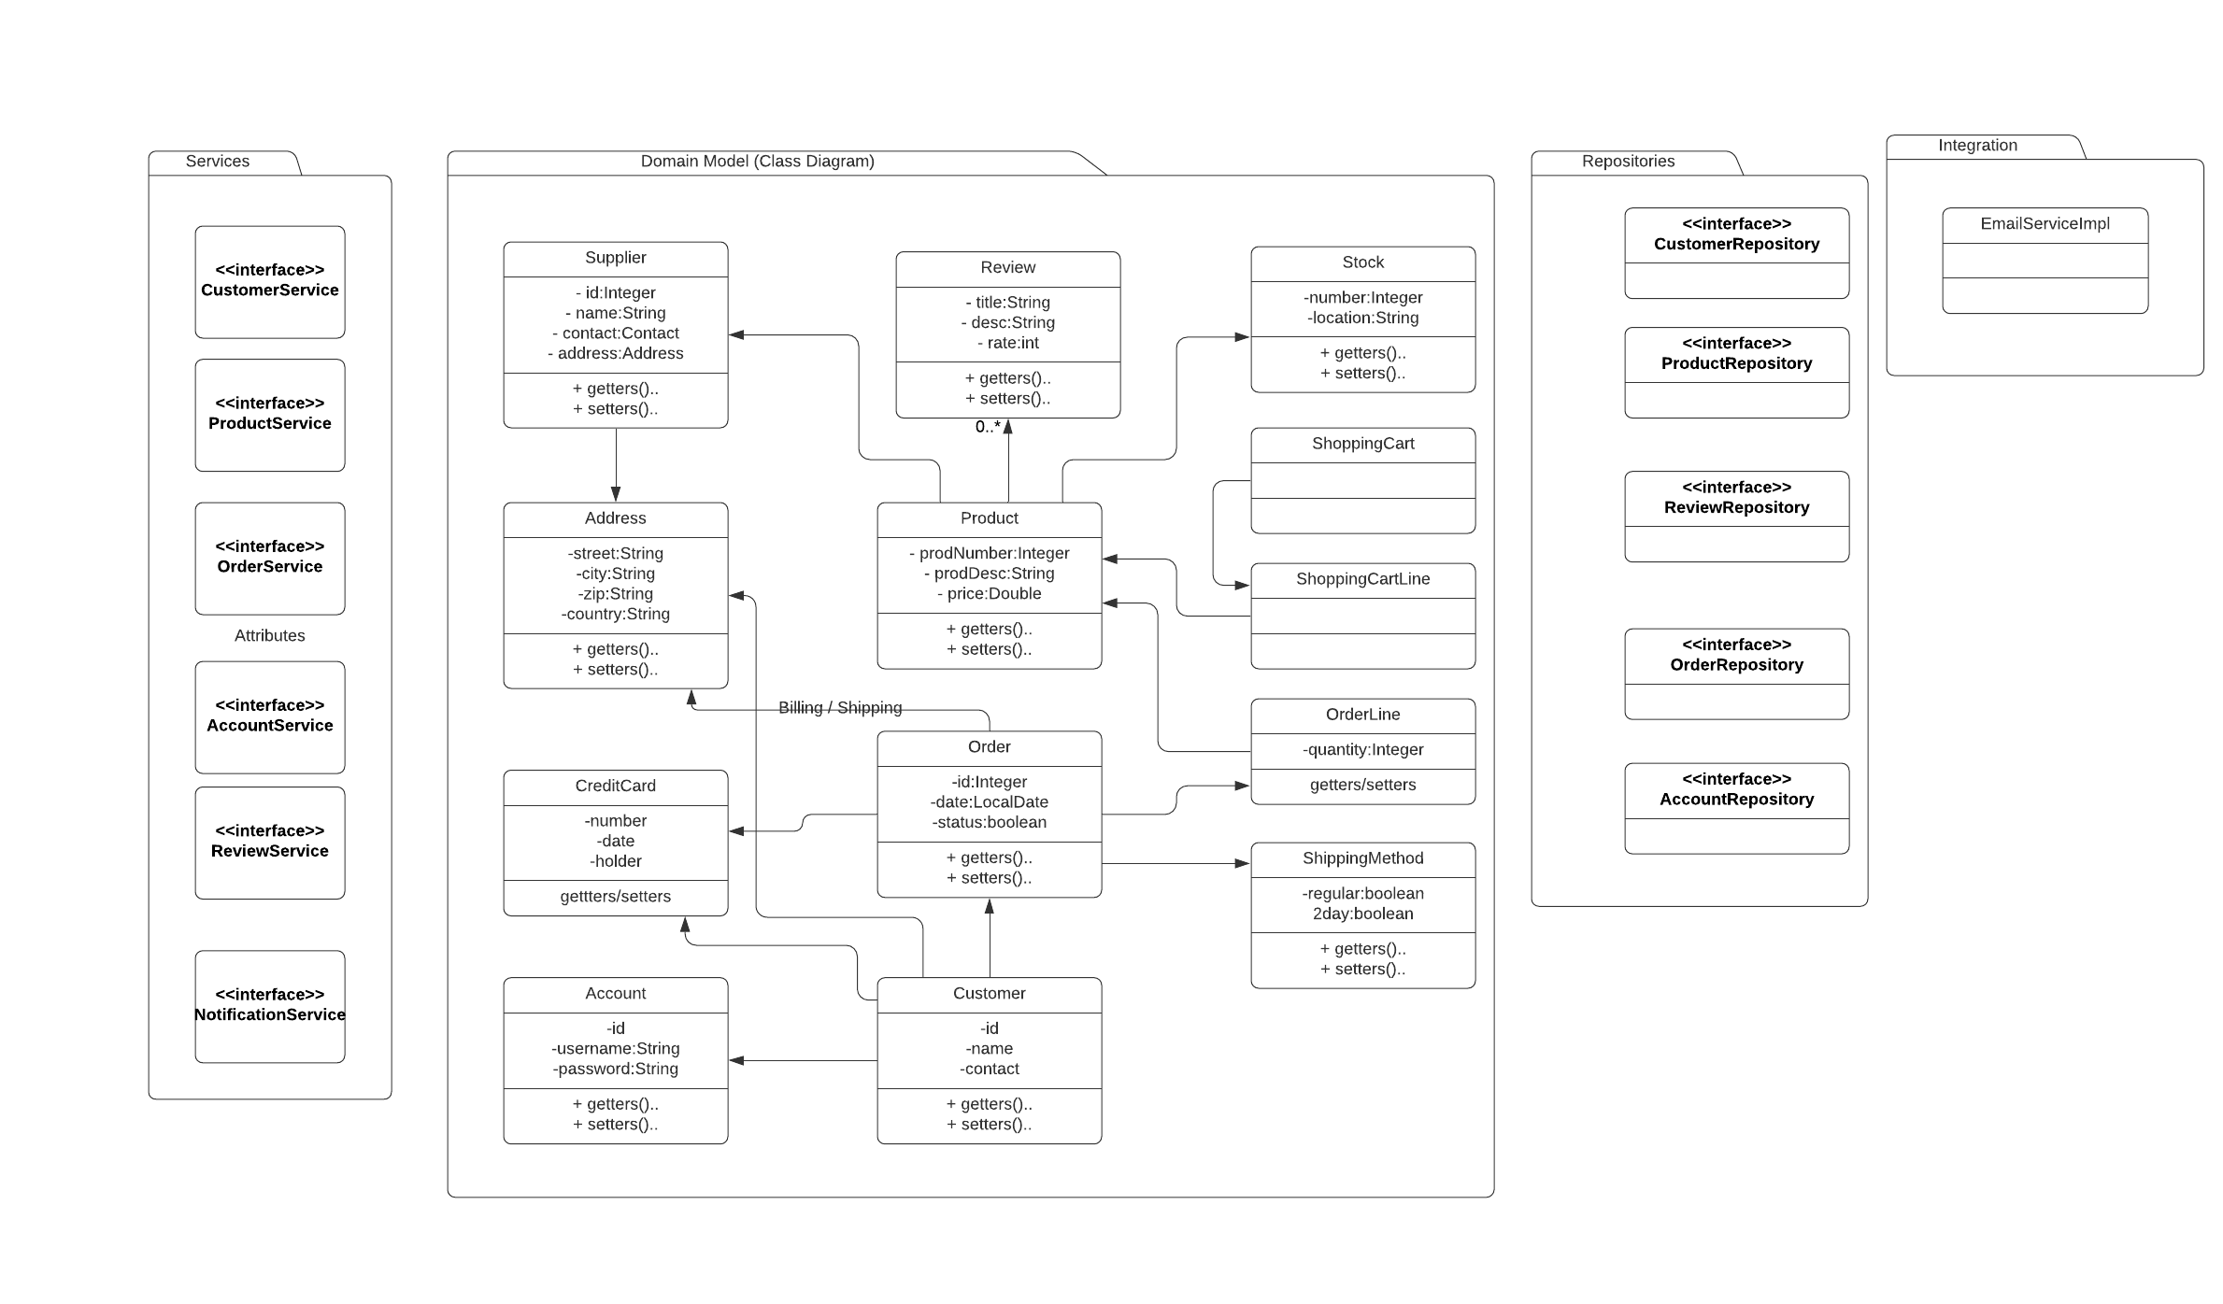

**Sequence Diagram for Order Place Use case:**

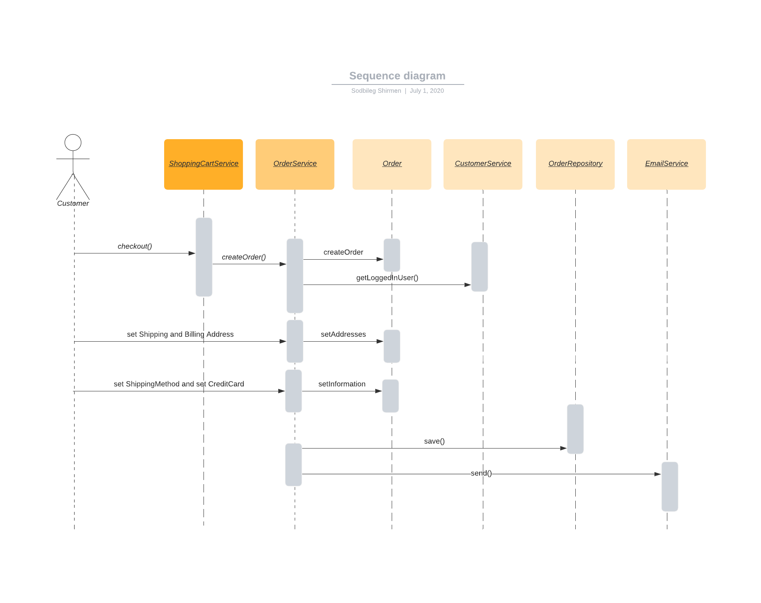

**Exercise 2**

Describe the different places where we can store state. Give the advantages and disadvantages of these different options.

1) Client side (browser)

Advantages: Can be scalable, High performance,

Disadvantages: Less security, defending browser state

2) Server side

Advantages: More secure

Disadvantages: Less scalable, defendant to server state

3) DB side

Advantages: High scalable, persist able

Disadvantages: less performance

**Exercise 3**

For each of the following integration possibilities, describe its advantages, its disadvantages and when you would apply it:

1) RMI *(Java Remote Method Invocation (Java RMI))*

Advantages: More secure,

Disadvantages: only Java, high coupled

When would be used: Socket programming (client-server architecture)?

2) Messaging (JMS)

Advantages: Scalable, Security, Modularity, Light coupled, Asynchronous

Disadvantages: Kafka, RabitMQ etc middleware required

When would be used: Almost all modern usage

3) SOAP

Advantages: Security

Disadvantages: old technology, complex XML data transfer

When would be used: integrate old technology

4) REST

Advantages: Light and simple, JSON data, asynchronous

Disadvantages: less security

When would be used: most modern usages

5) Serialized objects over HTTP

Advantages: Light, simple, websocket

Disadvantages: Tight coupled

When would be used: Java integration within one project

6) Database integration

Advantages: Simple, Secure

Disadvantages: high coupled

When would be used:

7) File based integration

Advantages: Patch process, secure

Disadvantages: high coupled

When would be used: while using file as data

**Exercise 4**

Read the following article:

<http://www.drdobbs.com/errant-architectures/184414966>

Explain the advantages and disadvantages of distributed systems.

* Advantage: Performance, Scalable
* Disadvantage: complex, more resource such network bandwidth, less secure